Showcasing achievements
This form enables the applicant company to showcase their achievements to the assessors during virtual site assessment.
The form is used while the preliminary discussion is going on, on the day of assessment. Please fill the appropriate sequence of visit path based on the discussion. The columns will enumerate the requirements of assessments (this data is to be kept with you and to be used for smooth assessment flow).
The requirements are:
- Presentation: To review data. This can be done by digitally sharing the screen and also sharing the files if asked for, by the assessor. Company can exert their confidentiality conditions.
- Observation: The assessor might ask to observe a particular process. The virtual guide should use the camera of his mobile to show this the way assessor wants to see it. The company can also choose to show some process if assessor agrees.
- Meet People: The assessors may seek the need to discuss with the operating people on the shop floor. The virtual guide (person carrying the mobile), would mediate this discussion during the virtual visit.
- Capture Photos: There would be a request from assessor to capture few photographs to support assessment report being submitted to esteemed Jury. Please capture these photos as a screen shot on mobile or with any suitable device (afterwards you may take a clear picture for sending to assessors).

Other requirements:
- Please assign the virtual guide, who would be equipped with smart phone and head phones.
- The Virtual guide should be knowledgeable about the application and technical information of your factory.
- The virtual guide should confirm about completing the needs identified by the assessors.

- Virtual guide would send the information and photos as agreed in the assessment.
Few Important things:
- It is expected that the Top Management (CEO/ VP /Plant Head/GM) is available on the day of the site visit.
- To support the application data, kindly keep your presentation/ data ready for site assessment.
- Virtual platform will be used between applicant company & assessor/s for site assessment
- Companies can choose suitable platform. (e.g. Cisco WebEx, Zoom, Google meet etc.) In case any support / queries, feel free to contact ACMA Award Team.

Guidelines for Virtual Assessment- Virtual call discussion

- Applicant company to use their own platform and share link with allocated assessor/s (2 days prior to assessment including trial of link). Note- this is considering recording authority with company only
- Assessor/s details will be shared with company prior to assessment date, will request company and assessor/s to communicate with each other in case of any data / information required for more clarification.
- Companies to show their good work done as a part of virtual plant visit thru digital mode (can use mobile camera or similar mode)
- Photographs which are requested by assessors needs to be shared by company by email for 5 good & 5 Opportunity for Improvement. (in case of new product design and development category application, please indicate testing facility, design work stations, benchmarking room and similar areas for capturing photos)
- The company coordinator will be the timekeeper to ensure that the time schedules allotted to various agenda points are adhered to by company representatives.
- All concerned persons will be made available with all the relevant documents to ensure time effectiveness.
- Specific attention is brought to the presentation on one or two unique initiatives that the company may have taken in the previous year.
- It is expected that the assessment process should be a learning experience for the company as well as for the assessors and hence all interactions with the assessors should be brief, to the point and well supported by data.

Virtual Site Assessment Plan
(Note- Virtual site assessment hours need to be covered in same day)
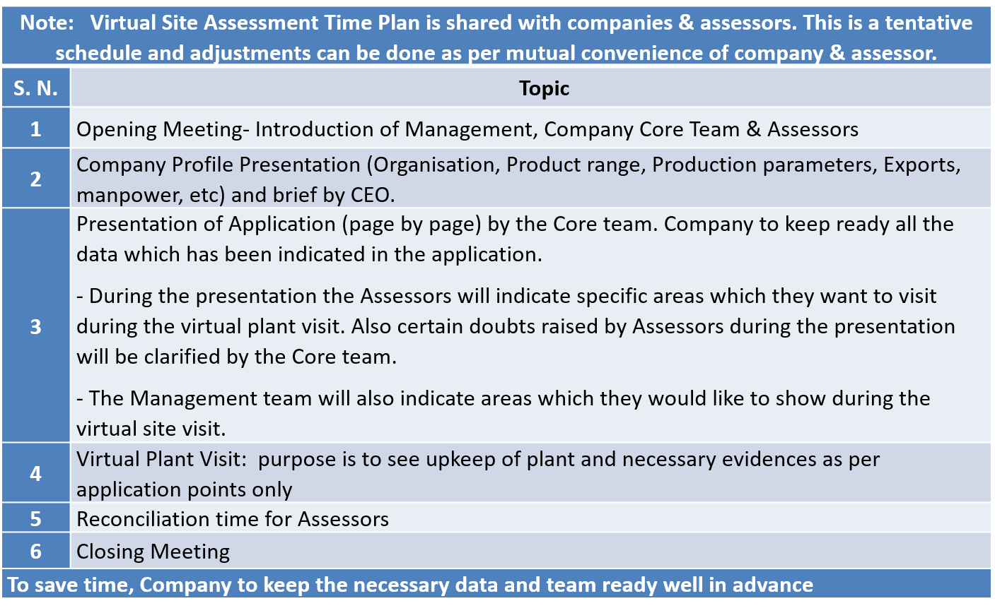

Note: It is mandatory to pay the Site Assessment fee as applicable prior to site Assessment or within 7 working days on receipt of invoice to process the application to next stage.

Guidelines for Virtual Assessment- Plant tour

The cameraman should:
- Wear head phones (not ear plug type)
- Travel in a wheel chair around the plant as much as possible
- Should capture photos wherever prompted for

The company may choose to use:
- Handy Cam connected to the meeting for better quality
- To connect to CCTV network to cover remote/ distant areas, also show history particularly for accidents

The assessors:
- Ought to fix the route with company before actual day of assessment
- Should request photo of their choice during assessment
- Suggest detour if necessary and if time/ resources permit

Following chart indicates the activities during assessment.
Sr | Location |   Presentation | Observation |   Meet People |   capture Photo
1 | Office/ façade |  |  |  | ✓
2 | Training facility | ✓ | ✓ |  | ✓
3 | Conference room | ✓
4 | Periphery |  |  |  | ✓
5 | Model line | ✓ | ✓ | ✓ | ✓
6 | Stores | ✓ | ✓ |  | ✓
7 | Toilet blocks |  | ✓ |  | ✓
8 | Shop areas such as Paint shop/ phosphating/ plating (if applicable) |  | ✓ | ✓
9 | E.G. Welding/ Brazing zone (if applicable) |  | ✓ | ✓
10 | Remaining shop areas… |  | ✓ | ✓ | ✓
Review data
Capture Photos
Talk to people
Observe process

Suggested route map for Virtual tour of shopfloor and facilities







T_{m}
T_{f}
office
1
2
3
4
5
6

